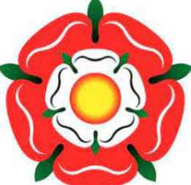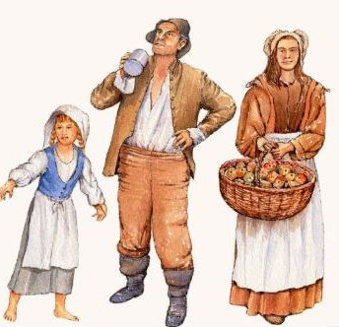
Winhills Primary Academy - Year 5 and 6 History
What was life like in Tudor times?
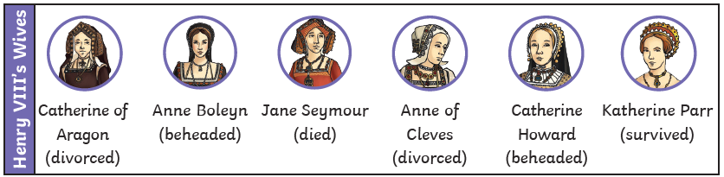
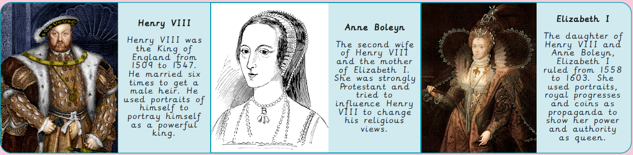
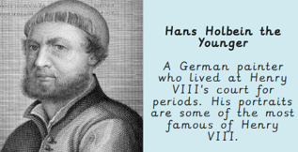
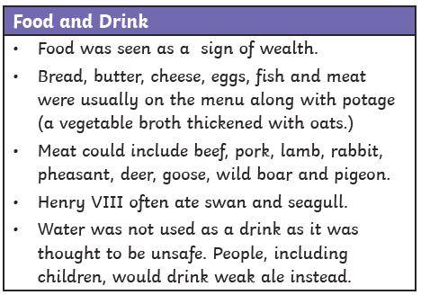
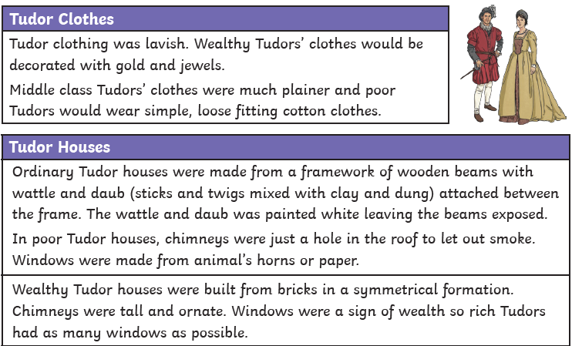
primary source | An original document (from the period being studied) that has not been changed in any way. | heir | Person who inherits money, property or a title when a family member dies (eg the throne when the present king or queen dies).
secondary source | A document or a record that was written later than the event being studied. | inventory | In Tudor times, this was a list of all the items and possessions owned by a person.
monarch | A person ruling over a place - usually a king or queen. | progress | In Tudor times, this was a monarch’s tour of the kingdom accompanied by his or her court.
reign | To rule over a country as a monarch. | propaganda | Information given out that may not be accurate but is intended to make people believe something or to hold a particular view.
portrait | A painting or drawing of a person. | propaganda
tyrant | A person or ruler who uses their power cruelly. | evidence | The information that historians extract from primary and secondary sources.

